Group member names: Michael Eastman, Mitchell Whyte, Alexander Overly, Narbada Archarya

**Exercise 3: Problem Solving** (5 points)

**Instructions:**

1. This is a group assignment. You only need to submit one solved exercise per group.
2. Provide your responses on this file, save it, and upload the file to the appropriate assignment response in blackboard.
3. You may upload as many attempts as you may like. Please note that only the most recent file uploaded file would be graded.
4. Do not handwrite any responses.
5. If you have any additional information you would like me to know about this assignment, you may provide that to me at the end of this document as a note.

**Identify each relationship type and write all of the business rules for the business shown below:**

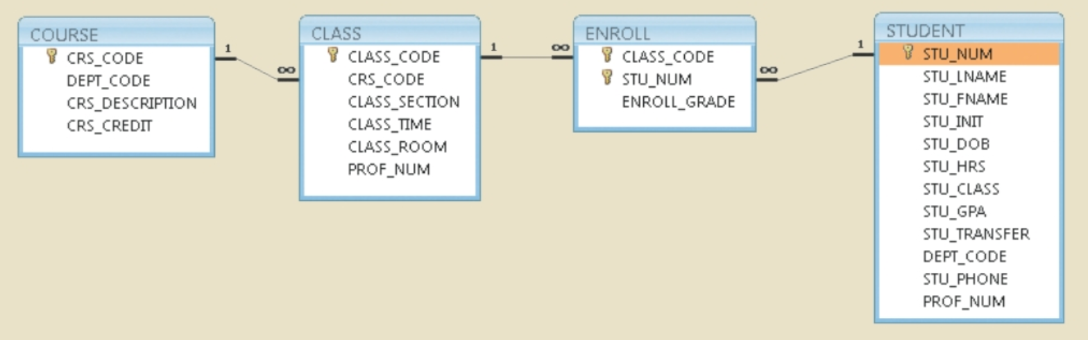

1. The relationship between course and class is a one-to-many relationship. A single course can have multiple different classes.
2. The relationship between class and enroll is a one-to-many relationship. Each class contains one or more that enroll.
3. The relationship between enroll and student is a many-to-one relationship. More than one student may enroll in a course.